Name: Luong Thi Uy Thieu

Class: DMA-B05

***HOMEWORK***

***DISCRETE MATHEMATICS***

***PROBLEM SET 02***

***Problem 1***

x irrational -> 1/x irrational

if 1/x is rational

=> 1/x = a/b (a,b Z)

=> x = b/a

=> x is rational

-Q=>-P = P=>Q

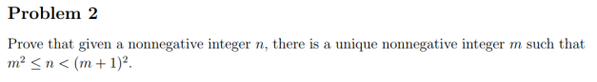

m2≤n<m+1^2

m≤ $\sqrt{n}$ <m+1

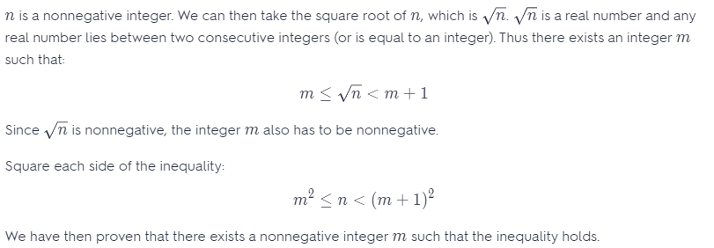

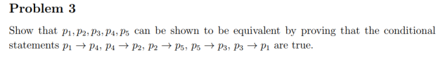

Assume p1 is true:

p1->p4 => p4 true

p4 -> p2 =>p2 true

…..

=> p5 true

Assume p1 is false:

p3->p1 => p3 is false

…..

p4 false

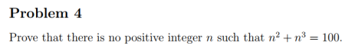

Assume there exits n

=> n^3 < 100 => = {1,2,3,4}

if n =1 f(n)=2

…..

n=4 f(n)=16+64=80

=> there is no positive integer n

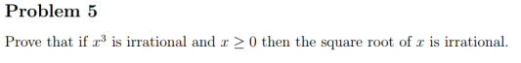

if $\sqrt{x}$ is rational => $\sqrt{x}$ = ab

x= (a/b)^2= a^2/b^2

x^3= a^6/b^6 => x^3 rational



m=3^x (x,y are integers)

n=3^y

m+n = 3^x + 3^y

=> m+n=3x(1+3y-x)

1+3^(y-x)) is indivisible by 3

=> m+n is not a power of 3

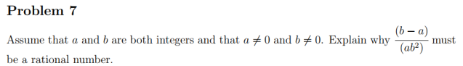

$\frac{b-a}{ab^{2}}$ = $\frac{1}{ab}-\frac{1}{b^{2}}$

a,b C Z => 1/ab is rational and 1/b^2 is rational

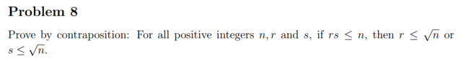

if r2>n and s2>n => (rs)2>n^2 => rs > n

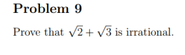

$\sqrt{2}$ + $\sqrt{3}$ = $\frac{a}{b}$ (a,b Z)

5+2 $\sqrt{6}$ = a^2/b^2

2 $\sqrt{6}$ = a^2/b^2-5

$\sqrt{6}$ = $\frac{a^{2}-5b^{2}}{2b^{2}}$ (contradiction)

Therefore, $\sqrt{2}$ + $\sqrt{3 }$ is irrational

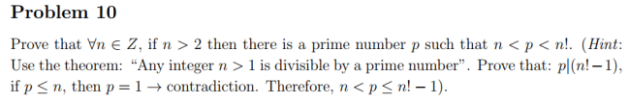

P: n>2 Q: n<p<n!

if n>2 => n<p<n!

assume –Q: n!≤p≤n

=> n!≤n

=> n =1 or n =2

=> 0<n ≤2 (contraposition)

=> -P

-Q => -P

Therefore, P => Q